Sample paper Ordinary Level

Sample paper Ordinary Level Question 1 (a)
A displacement vector, $\vec{b}$, has a magnitude of 15 km and a direction 𝛼 north of east, where $\tan{α=\frac{4}{3}}$
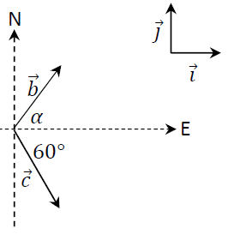
A second displacement vector, $\vec{c}$, has a magnitude of 10√3 km and a direction 60° south of east, as shown in the diagram.

- Express $\vec{b}$ and $\vec{c}$ in terms of the unit vectors $\vec{i}$ and $\vec{j}$.

- Calculate $\vec{b}$ ⋅ $\vec{c}$, the dot product of $\vec{b}$ and $\vec{c}$.

A third displacement vector, $\vec{d}$, is perpendicular to $\vec{b}$.
$\vec{d}\vec{i}$ = $-4\vec{i}$ + $k\vec{j}$.
- Calculate 𝑘.

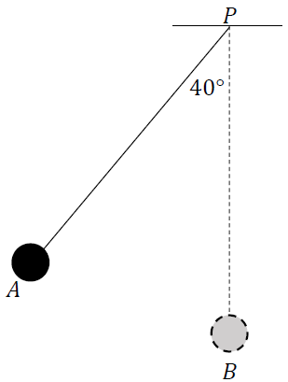
Sample paper Ordinary Level Question 1 (b)
A small smooth sphere of mass 2 kg is connected by a light inextensible string of length 3 m to a fixed point 𝑃.
The sphere is held at position 𝐴, where the taut string makes an angle of 40° to the vertical, as shown in the diagram. The sphere is then released from rest.

The motion of the sphere may be modelled using the principle of conservation of energy.
- Using this model, calculate the speed of the sphere as it passes through position 𝐵, when the string is vertical.
- Calculate the centripetal force on the sphere as it passes through 𝐵.
- Calculate the tension in the string when the sphere passes through 𝐵.

Sample paper Ordinary Level Question 2 (a)
During a treasure hunt competition, Seán must search at each of locations 𝐴, 𝐵, 𝐶, 𝐷 and 𝐸.
He may start at whichever of these location he chooses and he may visit the other locations in any order.
The estimated time, in seconds, needed to travel between any two of these locations is shown in the following table.
Time (s) | A | B | C | D | E
A | - | 290 | 205 | 630 | 210
B | 290 | - | 370 | 775 | 520
C | 205 | 370 | - | 425 | 145
D | 630 | 775 | 425 | - | 220
E | 210 | 520 | 145 | 220 | -

- Draw a network to represent this information. On your network the weights of the edges should represent the times to travel between the locations, which should be represented by labelled nodes.

In order to win the competition, Seán wants to spend as little time as possible travelling between the locations.
- Using an appropriate algorithm, find the minimum spanning tree for this network.
Name the algorithm you used. Relevant supporting work must be shown.

- At which location should Seán start? Justify your answer.

Sample paper Ordinary Level Question 2 (b)
The diagram below shows the scheduling network used in the assembly of an air filtering system.
The edges of the network represent the activities that have to be completed as part of the assembly and are labelled with the letters 𝐴 to 𝐿. The letters used to label the edges should not be taken as representing the order in which the activities happen. The time, in minutes, to complete each of the activities is shown.
The nodes of the network represent events or points in time during the assembly.
The source node is the time when the project begins and the sink node is the time when the project ends.

- Calculate the early time and the late time for each event.
Complete the diagram below by writing the early time (upper box) and late time (lower box) at the node representing each event.
Use the space below to show relevant supporting work, if necessary.

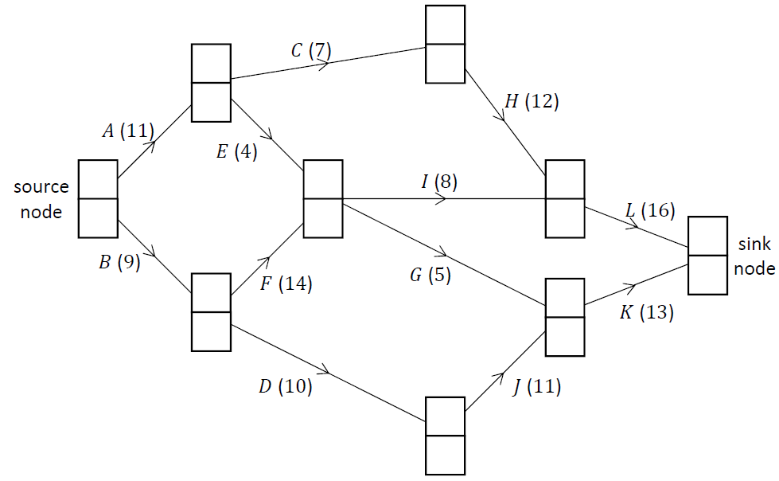

- Write down the critical path for the network.

- Write down the minimum time, in minutes, needed to assemble an air filtering system.

- Select any one non‐critical activity on the network and calculate its float, in minutes.

Sample paper Ordinary Level Question 3 (a)
Kate wishes to invest €150 000 in a long‐term investment scheme. Cormac is an investment broker. He offers Kate a guaranteed annual interest rate of 5.2% on her investment.
However Cormac will charge an annual fee of €3000, which will be deducted from her investment.
The value, 𝑃, in €, of Kate’s investment after 𝑛 years may be modelled by the difference equation:
𝑃_{n+1} = 1.052𝑃_{n} – 3000

where 𝑛 ≥ 0, 𝑛 ∈ ℤ and 𝑃₀ = 150 000.

- Solve this difference equation to find an expression for 𝑃_{n}, the value of Kate’s investment after 𝑛 years if she invests with Cormac.
- Calculate 𝑃₆, the value of Kate’s investment after 6 years if she invests with Cormac.

- Ruth, another investment broker, offers Kate a guaranteed annual interest rate of 4.3%.
Ruth will charge an annual fee of €2000.
Kate wishes to maximise the value of her investment after 6 years.
With which broker, Cormac or Ruth, should Kate invest? Justify your answer.

Sample paper Ordinary Level Question 3 (b)
A car dealership began to sell a new type of electric car in January 2020. The dealership sold eight of these cars in 2020. It sold twelve of them in 2021.
A sales person predicts that 𝑈, the number of such cars sold in any year, will be equal to twice the number of cars sold in the previous year plus three times the number of cars sold the year before that.
This prediction can be expressed as the second‐order difference equation:
U_{n+2} - 2U_{n+1} - 3U_{n} = 0

where 𝑛 ≥ 0, 𝑛 ∈ ℤ and U₀ = 8 and U₁ = 12.

This difference equation has the characteristic quadratic equation 𝑥² - 2𝑥 - 3 = 0.

- Solve this quadratic equation, i.e. calculate the two roots of the equation.
- Hence or otherwise, solve the difference equation to find an expression for 𝑈_{n} in terms of 𝑛.
- Calculate the number of such cars that the model predicts the dealership will sell between the start of 2020 and the end of 2025.

Sample paper Ordinary Level Question 4
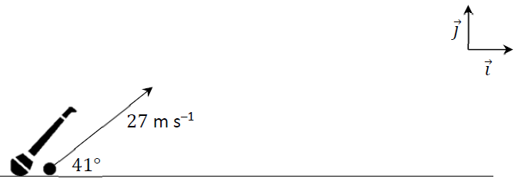
A camogie player strikes a sliotar off the horizontal ground. It travels with an initial velocity of 27 m ^{–1} at an angle of 41° to the ground, as shown in the diagram.

- Express the initial velocity of the sliotar in terms of the unit vectors $\vec{i}$ and $\vec{j}$.
The motion of the sliotar may be modelled as projectile motion in a vertical plane, ignoring the effects of wind and the effects of air resistance.

- Calculate the speed and direction of the sliotar 0.5 s after it is struck.
- Calculate the time it takes for the sliotar to reach its maximum height.
- Calculate the maximum height of the sliotar.
- The crossbar in a camogie goal is 2.5 m above the ground. Calculate the time interval during which the sliotar is at least 2.5 m above the ground.
- The graph below shows the predicted path of the sliotar when the effects of wind and the effects of air resistance are ignored. The graph is not drawn to scale.
- Using the same axes, sketch the path you would expect the sliotar to take if the model took into account the effects of air resistance (but not the effects of wind).
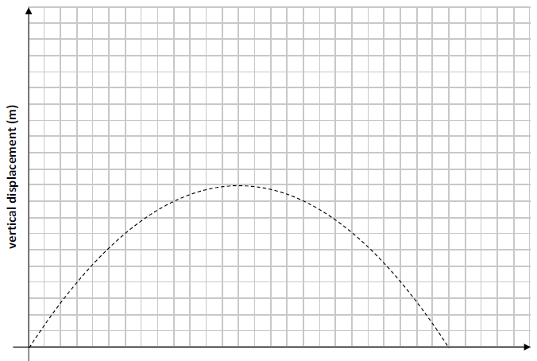

Sample paper Ordinary Level Question 5 (a)
A small smooth sphere, 𝑃, of mass 𝑚, travels along a horizontal surface at a constant speed of 8 m s^{–1}. It collides with another small smooth sphere, 𝑄, of mass 3𝑚, which is at rest.
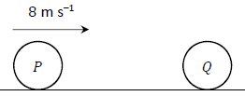
The coefficient of restitution between the spheres is $\frac{3}{8}$.

- Calculate the velocity of 𝑃 and the velocity of 𝑄 after impact.
- Calculate, in terms of 𝑚, the loss in kinetic energy due to the impact.

Sample paper Ordinary Level Question 5 (b)
A tennis ball bounces across a tennis court. It is found that some of the ball’s kinetic energy is lost each time it hits the ground, such that the horizontal range, 𝑅, of each bounce is 70% of the range of the previous bounce.
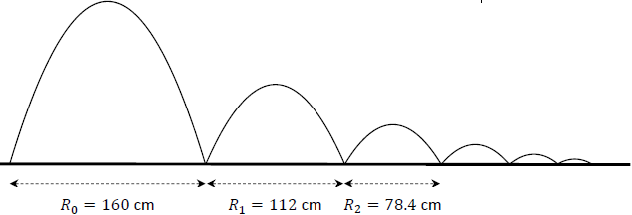
The ranges of the first three bounces are given in the diagram below.

This geometric sequence may be represented by the difference equation:

𝑅_{n+1} = 0.7𝑅_{n}.
where 𝑛 ≥ 0, 𝑛 ∈ ℤ and 𝑅₀ = 160 cm.

- Solve this difference equation to find an expression for 𝑅_{n} in terms of 𝑛.
- Calculate 𝑅₆ in cm, to two decimal places.
- Calculate 𝑆₆, the sum of the ranges of the first seven bounces, in cm, to two decimal places.
- Write a difference equation for the horizontal ranges of the bounces if no kinetic energy is lost when the ball hits the ground.

Sample paper Ordinary Level Question 6
Block 𝐴, of mass 4 kg, rests on a rough horizontal table. It is connected to block 𝐵, of mass 6 kg, by a light inextensible string which passes over a fixed smooth pulley at the edge of the table.
When the system is released from rest, block 𝐴 is 40 cm from the pulley.
The coefficient of friction between block 𝐴 and the table is ½.

- Draw diagrams to show the forces acting on blocks 𝐴 and 𝐵 while they are moving.
- Calculate the frictional force acting on block 𝐴 while it is moving.
- Calculate the tension in the string and the acceleration of the blocks while they are moving.
- Calculate the speed of block 𝐴 when it reaches the pulley.
- Explain why it would not be appropriate to model this problem using the principle of conservation of energy.

Sample paper Ordinary Level Question 7 (a)
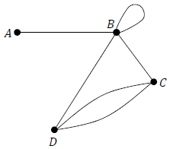
Write the adjacency matrix that represents the graph shown below.

Sample paper Ordinary Level Question 7 (b)
Matrix P = $\left[\begin{matrix}2 & 1 \\ 0 & 1\end{matrix}\right]$. Matrix Q = $\left[\begin{matrix}3 & 0 \\ -2 & 2\end{matrix}\right]$. Calculate PQ.

Sample paper Ordinary Level Question 7 (c)
A coach operator wishes to design a new four‐day coach route from city 𝐴 to city 𝐽.
The coach will depart from city 𝐴 on Monday morning and should arrive in city 𝐽 on Thursday evening. On Monday night the coach will stop in city 𝐵, 𝐶 or 𝐷. On Tuesday night the coach will stop in city 𝐸, 𝐹 or 𝐺. On Wednesday night the coach will stop in city 𝐻 or 𝐼.
Passengers may begin or end their journey at any city.
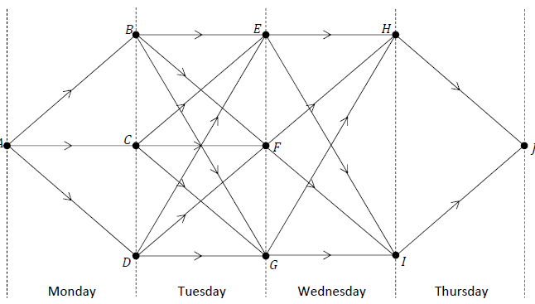
The operator draws the network shown below to help him design this route.
The table below gives the number of passengers who wish to travel between pairs of cities on each day.

Journey | Number of passengers |  | Journey | Number of passengers
𝐴 to 𝐵 | 32 |  | 𝐷 to 𝐹 | 45
𝐴 to 𝐶 | 27 |  | 𝐷 to 𝐺 | 23
𝐴 to 𝐷 | 19 |  | 𝐸 to 𝐻 | 43
𝐵 to 𝐸 | 36 |  | 𝐸 to 𝐼 | 34
𝐵 to 𝐹 | 41 |  | 𝐹 to 𝐻 | 17
𝐵 to 𝐺 | 45 |  | 𝐹 to 𝐼 | 26
𝐶 to 𝐸 | 22 |  | 𝐺 to 𝐻 | 32
𝐶 to 𝐹 | 38 |  | 𝐺 to 𝐼 | 46
𝐶 to 𝐺 | 29 |  | 𝐻 to 𝐽 | 36
𝐷 to 𝐸 | 30 |  | 𝐼 to 𝐽 | 25

Use Bellman’s Principle of Optimality to calculate the path from city 𝐴 to city 𝐽 which maximises the number of passengers who use the coach.
Relevant supporting work must be shown.

Sample paper Ordinary Level Question 8
Pole 𝑃 and traffic lights 𝐿 lie 800 m apart on a straight level road, as in the diagram below.
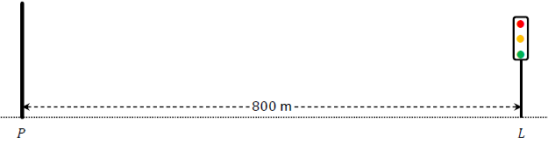
A car passes 𝑃 travelling towards 𝐿 with a speed of 5 m s^{–1} and an acceleration of 0.4 m s^{–2}.
At the same moment, a motorcycle passes 𝐿 travelling towards 𝑃 with a speed of 4 m s^{–1} and an acceleration of 0.6 m s^{–2}.

- Calculate the speed of the car 15 s after it passes 𝑃.
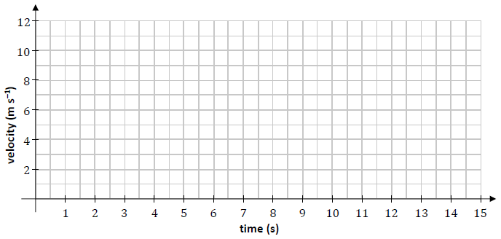
- Draw a velocity‐time graph for the motion of the car for the first 15 s after it passes 𝑃.

- Write an expression for 𝑠_{c}(𝑡), the displacement of the car from 𝑃 at any time 𝑡.
- Write an expression for 𝑠_{m}(𝑡), the displacement of the motorcycle from 𝐿 at any time 𝑡.
- The car and the motorcycle pass each other after 𝑇 seconds. Calculate 𝑇.

At the instant that the car and motorcycle pass each other, the car stops accelerating and continues travelling at the velocity it has at that instant.

- Calculate the total time it takes the car to travel from 𝑃 to 𝐿.

